Question 1:
#region Question 1

class Game:
'''
A simple number-guessing game having following features.
1. Displaying full name of student and their ID.
2. Generating a random number between 1 and 20 (inclusive).
3. Player having 6 changes at max to guess the number correctly.
4. Hint system will be provided for the player to predict how far the given number is.
5. Game ends when the player guesses the correct number.
'''

MINNUM = 1
MAXNUM = 20

MAXATTEMPTS = 6

# Different hints for the player on how far the number is.
HINTS = {
range(2) : 'Too Close',
range(5) : 'Close',
range(8) : 'Far',
range(10) : 'Too Far'
}

def __init__(self) -> None:
'''
Initializes the data members required for the game.
'''

self.remaining_attempts = self.MAXATTEMPTS
self.correct_number = self.generate_number()
self.guessed_number = -1

def generate_number(self) -> int:
'''
Generates a random number for guessing by the player.
'''
return random.randint(self.MINNUM, self.MAXNUM)

def hint(self, difference) -> str:
'''
Provides hint to the player how far the number is for predicting the number correctly.

# Parameters

difference : int
Calculated difference between the predicted number and the actual number.
Example: 2
'''

# for hint_key in self.HINTS.keys():
# if difference in hint_key:
# return self.HINTS[hint_key]

# return self.HINTS[0]

if difference > 0 and difference <= 2:
return 'Too Close'
elif difference > 2 and difference <= 5:
return 'Close'
elif difference > 5 and difference <= 8:
return 'Quite Far'
else:
return 'Too Far'

class Player(Game):
'''
Player playing the game.
'''

def __init__(self, name, id):
'''
Player having its name and ID.

# Parameters

name : str
Name of the player.

id : str
ID of the player. (For the simplicity, it is a string.)
'''
self.name = name
self.id = id
self.game = Game()

def guess_number(self, guessed_number) -> bool:
'''
Player attempts to guess the number.

# Parameter

guessed_number : int
Number to validate whether it is guessed correctly.

# Returns

True - Guess is correct.
False - Guess is incorrect.
'''

return self.game.correct_number == guessed_number

def play(self) -> None:
'''
Starts the game for the player to play.
'''

print('Welcome to the Guess-Number Game!')
print('Player Details:')
print(f'Name: { self.name }')
print(f'ID: { self.id }')
print('The Game Begins!')

while True:
try:
self.guessed_number = int(input('Guess the number: '))
except ValueError:
print(f'Guessed number is not in correct format! Please enter a number between { Player.MINNUM } and { Player.MAXNUM }.')
continue

# Validating the input.
if self.guessed_number >= Player.MINNUM and \
self.guessed_number <= Player.MAXNUM:

if self.guess_number(self.guessed_number):
print(f'Congratulations! The { self.guessed_number } is correct!\nYou have won the game!')
break
else:
self.game.remaining_attempts -= 1

if self.game.remaining_attempts == 0:
print('Game over!')
break
else:
print(f'Number incorrect!\nAttempts Remaining: { self.game.remaining_attempts }')
print(f'Hint: { self.hint(abs(self.game.correct_number - self.guessed_number)) }')
continue
else:
print(f'Guessed number is not in correct format! Please enter a number between { Player.MINNUM } and { Player.MAXNUM }.')

#region Play-Again

# play_again = input('Do you want to play this again (Y/N)? ')

# if type(play_again) == str and play_again.upper() == 'Y':
# Player.play(self)
# else:
# print('Thank you for playing the game!')

#endregion

print('Thank you for playing the game!')

#endregion

#region Unit-Testing

if __name__ == '__main__':
rachit = Player('Rachit', 'C0902810')
rachit.play()

#endregion

Output:
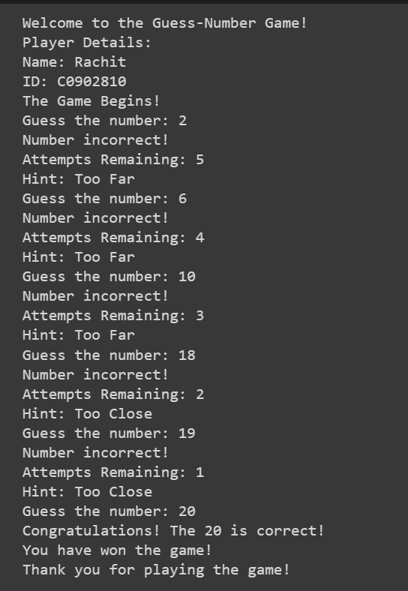
Question 2:
#region Question 2

class DisplayFibonacciSeries:
'''
Displays numerious fibonaicc series.
'''

def display_fibo(self, limit = 10) -> None:
'''
Displays the Fibonacci Series for the given `limit`.
NOTE: This function only displays the Fibonacci Series and does not returns anything.

# Parameters

limit : int
Limit for displaying the Fibonacci Series.
Default: 10

# Example

Having `limit` = 10
Output: 0 1 1 2 3 5 8 13 21 34
'''

# Declaring the variables for displaying the Fibonacci Series.
# First, Next, First + Next, and so on.
first = 0
next = 1

# Iterating till the given `limit`.
for iterations in range(limit):

# Displaying the first instance.
print(first, end = ' ')

# Performing swapping operation and calculating the next number for the Fibonacci Series.
first, next = next, first + next

#endregion

#region Unit-Testing

if __name__ == '__main__':
print(f'Fibonacci Series:')
DisplayFibonacciSeries().display_fibo()

#endregion

Output:
